**PAPER GUIDELINES FOR THE AFRICAN MEMBRANE SOCIETY INTERNATIONAL-2 (AMSIC-2) CONFERENCE**

E. NXumalo1, M. Cissé2 and R. Ben Amar3 Postal address

Email address

1University of South Africa, Nanotechnology & Water Sustainability Research Unit

2Université Cheikh Anta Diop, Sénégal

3Faculté des Sciences et Techniques, Tunisia

SUMMARY: This template file provides essential information on how to prepare and submit paper for the 2018 conference in the City of Johannesburg, South Africa. Please follow them as precisely as possible. You do not need to send an abstract but we should receive your article before the deadline, which is **March 31st 2018**. If your paper is accepted, you should send the **final version including the reviewer’s corrections by May 30th 2018**. **It is recommended that final papers comprise between two and six (6) A4-pages and 4 MB in a file size.** The title is in bold capital letters and centered at the top of the first page. It must be followed by the author(s) name(s), organization(s). Leave one bank line between the title and the name of the author(s). When

several authors prepare a paper, the name of the corresponding author should be underlined. The name of each one’s organization should be easily distinguished**.** Type a summary of your abstract in less than 10 lines, followed by the keywords up to 5 words.

**Keywords**: renewable energy, ultrafiltration membrane, protein recovery, paper size (up to 5 words)

# INTRODUCTION

In order to complete your abstract, replace all parts of this text with your presentation without changing any layout (font type and size, line spacing, page margins and so on). DO NOT insert page numbers or page headers/footers. **Papers not meeting these guidelines may be excluded from the conference proceedings**. These instructions have been formatted in the manner in which you should prepare your manuscript, thus you may use this document as an example.

The manuscripts are to be formatted using A4-size paper (210 mm x 297 mm), single-spaced except for headings and subheadings. The preferred font of text is Times New Roman -10 point (shown here), or as close a match as possible. Full justification should be used when available. Bold should be used for the paper title and major headings. Use a two-column format as this template except title, author(s), affiliation(s), summary, and keyword(s). Each column is 80 mm wide with spacing of 10 mm between columns (total width is 170 mm). All the margins are to be 25 mm including the title page.

# SUBMISSION AND NOTIFICATION OF PAPER

* 1. **Deadline of Paper**

You should send your paper at https://easychair.org/conferences/?conf=amsic2 and contact this email address if you have any questions : [nkmerzouk@gmail.com.](mailto:nkmerzouk@gmail.com) You shoud send your paper directly (abstract not needed) by **March 31st 2018**. Your manuscript must be saved via Microsoft Word doc or Adobe Acrobat pdf file.

# Review and Notification

The submitted paper will be reviewed by the Program Committee, and then the corresponding author will be notified of the paper’s acceptance or rejection, and oral or poster presentation by **April 30th 2018.**

If your paper is accepted, you should prepare and send the **final version by May 30th 2018**. You should register your participation to secure your

presentation on the final conference program.

# PREPARATION OF MANUSCRIPT

* 1. **Manuscript length and volume limits**

Papers are limited to four (4) A4-pages (including all figures) and 4 MB in a file size. **Final accepted manuscripts should not exceed (6) six pages**.

# Title block

The title should appear in **BOLD CAPITAL LETTERS** with **12 pt. of Times New Roman** centered across both columns without underlining. Type the author’s name and affiliation in upper and lower case letters, centered and double-spaced below the title. For multiple organizations, use superscripted numbers to identify organization and list the organizations after the author list.

# Headings

Major captions (headings) are to be in capitals without underlining, centered over one column and bold. Subheadings should start at the left-hand margin on separate lines. A blank line space should be placed both before and after each heading or subheading. There should be no blank line after the title of the sections. Sub caption begins with the

upper case. If you use sub-sub captions, please type it with normal plain letters. The fonts of text should be **Times New Roman of 10 pt**. in size with single line spacing. At the beginning of each paragraph please indent as on this document.

# Equations

Equations are to be numbered consecutively throughout the paper. The equation number, in parentheses, should be placed flush with the right-hand margin of the column. When possible, use an equation editor.

columns of your table. Also, do not use the “columns” feature to create tables. When possible the table data should be centered within a single column. If there is not enough space left on the page to allow for your table, end your page and continue on the next page.

# CONCLUSION

Correction of papers after submission is possible before the deadline. An update version should be sent to https://easychair.org/conferences/?conf=amsic2 or the email account: [nkmerzouk@gmail.com.](mailto:nkmerzouk@gmail.com)

E = mc2

(1)

The copyright of accepted papers and Proceedings belongs to the authors. The AMS 2018

Leave a blank line before and after equations.

# Illustrations and graphics

Hand-written lettering on figures is not acceptable. The use of **color** in figures and photos is recommended but please keep in mind that total file size never exceeds 4 MB.

Figures and tables should be identified by Arabic numerals and positioned within the text. Illustrations and graphics may be one- or two-columns wide and should include captions or titles.

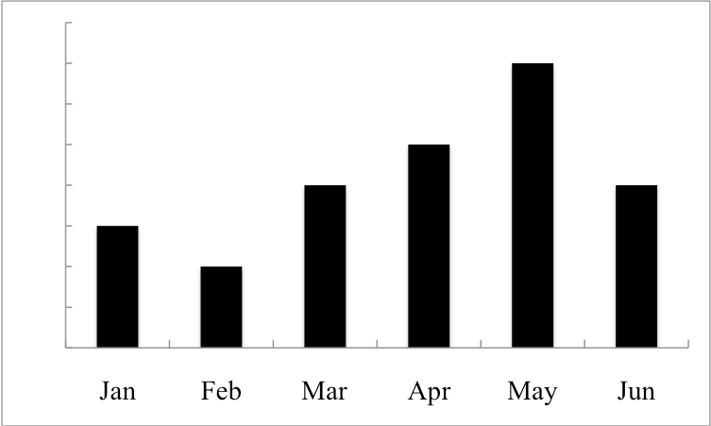

Figure 1. Solar energy irradiation Table 1. Countries and cities

When possible, use a table editor or tabs to create tables. Please do not use spaces to align the

|  |  |  |  |
| --- | --- | --- | --- |
|  | Mali | Morocco | Cameroun |
| Cities | Bamako | Rabat | Yaoundé |

Organizing Committee has a right to publish paper books and proceedings for this conference.

# ACKNOWLEDGMENT

Thank you for submitting your paper. We are looking forward to seeing all you at the next AMS conference in Tunisia.

# REFERENCES

References are to be listed and numbered at the end of the paper with a left-justified format. The text which refers the references should show them as [1]. Titles of journals and books should be written in *Italic* script. If *italic* script is not available, titles may be bold. Volume numbers in references should be typed in bold. A blank line should be used to separate references in lists as follows:

1. G. Eason, B. Noble, and I. N. Sneddon, “On certain integrals of Lipschitz-Hankel type involving products of Bessel functions,” *Phil. Trans. Roy. Soc. London*, vol. A247, pp. 529–551, April 1955.
2. J. Clerk Maxwell, *A Treatise on Electricity and Magnetism*, 3rd ed., vol. 2. Oxford: Clarendon, 1892, pp.68–73.
3. I. S. Jacobs and C. P. Bean, “Fine particles, thin films and exchange anisotropy,” in *Magnetism*, vol. III, G. T. Rado and H. Suhl, Eds. New York: Academic, 1963, pp. 271–350.
4. R. Nicole, “Title of paper with only first word capitalized”, *J. Name Stand. Abbrev.*, in press.
5. M. Young, *The Technical Writer's Handbook*. Mill Valley, CA: University Science, 1989.